1. SAP: What is SAP? 2
2. SAP Evolution 3
3. SAP Competitors 6
4. SAP Landscape 8
5. SAP Three-Tier Architecture 9
6. SAP S4 HANA Deployment Options 10
7. SAP S4 HANA Deployment Models 11
1. SAP S/4HANA On-Premises 11
2. SAP S/4HANA Private Cloud 12
3. SAP S/4HANA Public Cloud (Multi-Tenant) 13
4. SAP S/4HANA Public Cloud (Single Tenant) 14
5. Hybrid Configurations 15

- SAP: What is SAP?
SAP is the acronym for “Systeme, Anwendungen, Produkte in der Datenverarbeitung” or “Systems Applications and Products in Data Processing”.
SAP, by definition, is the name of the ERP (Enterprise Resource Planning) software as well as the name of
the company.
SAP was started in 1972 by five former IBM engineers who wrote programs for mainframe computers to help industrial companies control their manufacturing processes. The group proposed their real-time data processing idea to IBM, but it was not pursued. When IBM transferred the project, they were working on to another unit, the five engineers left IBM, believing in the potential of their concept, to establish their own company and founded SAP.

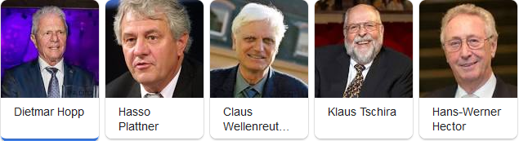

In 1972, the five former IBM employees -- Dietmar Hopp, Hans-Werner Hector, Hasso Plattner, Klaus Tschira, and Claus Wellenreuther launched a company called Systems, Applications, and Products in Data Processing in Mannheim, Germany. Their vision was to develop standard application software for real-time business processing.



ERP systems are fundamental to rationalising complex business processes and ensuring that data is accurate and accessible. SAP delivers a suite of features that helps organizations manage these processes effectively. SAP gives companies a unified 360-degree view of their operations, by integrating different operational areas such as financial, human resources, supply chain, inventory information etc.

Today, SAP is one of the largest enterprise software companies in the world, serving over 400,000 customers across more than 180 countries, and continues to drive digital transformation globally.

SAP positions itself as more than just a software company, rather as a strategic partner enabling organizations to thrive in an increasingly complex and dynamic business landscape.

- SAP Evolution

SAP has undergone significant evolution since its founding in 1972, transforming from a small start-up focused on financial software to a global leader in enterprise application software. Below is an outline of its key milestones and innovations:

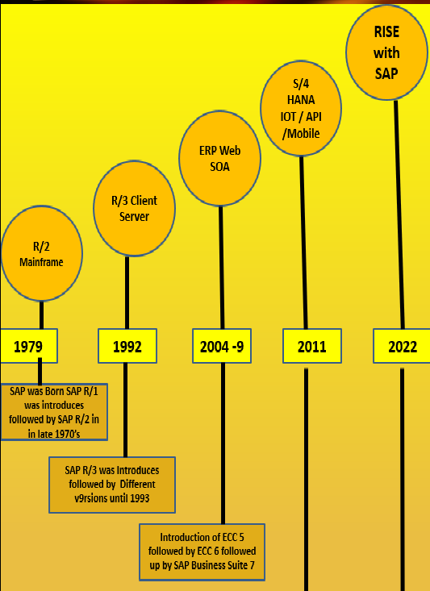

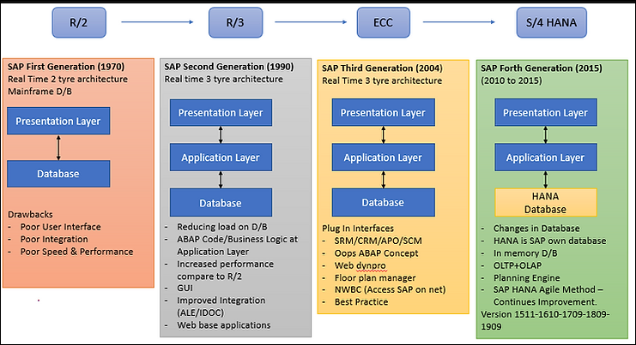

1. The Early Years (1972–1980s): SAP R/1 and R/2
SAP R/1 (1972):
SAP's first product, a real-time financial accounting system, was designed for mainframe computers. Known as RF (Real-time Financials), it marked the beginning of SAP's ERP journey.
- Focused solely on financial processes.
- Limited to single-user operations.
SAP R/2 (1979):
SAP introduced R/2, a more advanced ERP system that integrated various business processes like finance, materials management, and production planning.
- Enabled multi-user functionality on mainframe computers.
- Offered localization, catering to different tax and accounting regulations globally.
- Set the stage for SAP’s dominance in the enterprise software market.

2. The Client-Server Era (1990s): SAP R/3
SAP R/3 (1992):
SAP launched R/3, which revolutionized the ERP market by transitioning from mainframe systems to a client-server architecture.
- Supported multiple platforms (Windows, Unix, etc.).
- Integrated modules for finance, sales, human resources, supply chain, and more.
- Enabled real-time data processing across departments.
R/3’s scalability and flexibility made it popular among large enterprises, leading to SAP's rapid global expansion

3.The Internet Era (2000s): MySAP and NetWeaver
MySAP (2000):
SAP introduced MySAP to adapt to the rise of the internet and e-business. This suite extended traditional ERP functionalities with web-based solutions.
- Included tools for customer relationship management (CRM), supply chain management (SCM), and business intelligence (BI).
- Allowed businesses to connect with suppliers, customers, and partners online.
SAP NetWeaver (2004):
SAP NetWeaver became the technical foundation for SAP solutions, enabling seamless integration of SAP and non-SAP applications.
- Supported web services and service-oriented architecture (SOA).
- Simplified customization and integration of business processes.

4.The Digital Transformation Era (2010s): SAP HANA and Cloud Solutions
SAP HANA (2011):
SAP introduced HANA, its in-memory database and analytics platform, designed for high-speed processing and real-time analytics.
- Enhanced data processing speeds significantly.
- Laid the foundation for next-generation ERP systems.
SAP Cloud Solutions:
With the growing importance of cloud computing, SAP acquired several companies, such as:
- SuccessFactors (2011) for human capital management (HCM).
- Ariba (2012) for procurement and supply chain collaboration.
- Concur (2014) for travel and expense management.
- These acquisitions helped SAP strengthen its cloud offerings.

5. The Intelligent Enterprise Era (2015–Present): SAP S/4HANA
SAP S/4HANA (2015):
SAP launched S/4HANA, a next-generation ERP suite built on the SAP HANA platform.
- Provided real-time insights and advanced analytics.
- Simplified data models and enhanced user experience with SAP Fiori.
- Designed for cloud, on-premise, and hybrid deployments.
Focus on AI, Machine Learning, and IoT:
SAP integrated cutting-edge technologies into its solutions to enable predictive analytics, process automation, and smarter decision-making.
Rise of SAP Business Technology Platform (BTP):
BTP became a key enabler for integrating, developing, and extending applications, emphasizing flexibility and customization.

SAP's evolution reflects its commitment to innovation and adaptability:
- 1970s–1980s: Established foundational ERP systems (R/1 and R/2).
- 1990s: Pioneered client-server ERP with R/3.
- 2000s: Expanded into web-based and integrated solutions with MySAP and NetWeaver.
- 2010s: Shifted focus to in-memory computing (HANA) and cloud technologies.
- 2020s: Embraced intelligent enterprise technologies (AI, IoT, machine learning) with S/4HANA and BTP.
Today, SAP continues to lead digital transformation efforts, empowering organizations to become more agile and data-driven.

- SAP Competitors

While SAP remains a leading player in the ERP market, several formidable competitors offer comparable solutions to meet the organization’s diverse needs. Oracle ERP Cloud, Microsoft Dynamics 365, Infor ERP, Salesforce ERP, etc., are just a few examples of the top competitors that provide robust functionality and cater to various industries.

Ultimately, an ideal ERP choice depends on the organization’s specific requirements, budget, and long-term goals. Businesses looking for the best ERP system should conduct a thorough evaluation, considering factors such as scalability, integration capabilities, industry-specific functionality, user experience, and overall costs.

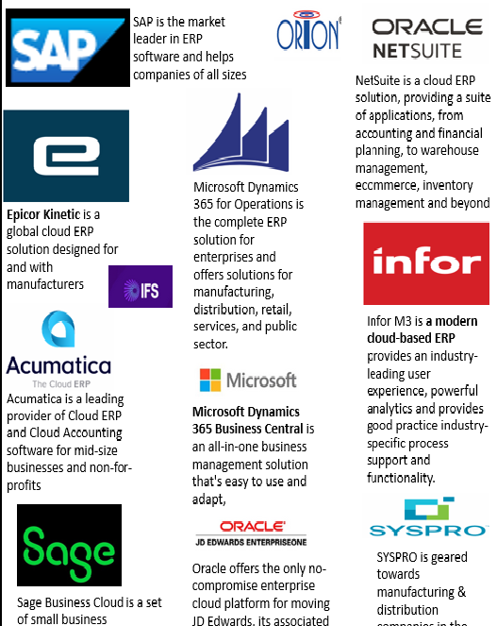

Let's review some of the most popular alternatives to SAP ERP and competitive ERP software to SAP below:
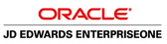 | Oracle, with its robust suite of ERP solutions, competes directly with SAP in the large-scale business segment. The scalability of Oracle ERP Cloud and its integration capabilities make it perfect and one of the most preferred choices for enterprises with complex and extensive operational requirements.  Oracle ERP Cloud caters to large enterprises with a comprehensive suite of applications covering finance, procurement, project management, and more. The platform's advanced analytics and automation capabilities contribute to improved efficiency and decision-making for large-scale businesses.
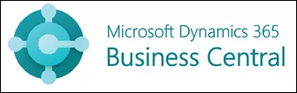 | Microsoft Dynamics 365 Business Central stands out as a strong competitor for SMEs. It renders a user-friendly interface and a range of integrated applications for finance, sales, and customer service. The scalability and flexibility of Dynamics 365 make it an attractive option for growing businesses.  Dynamics 365 Business Central provides a seamless experience for small and medium-sized enterprises, combining ERP and CRM functionalities. The platform's integration with other Microsoft products, such as Office 365, enhances collaboration and productivity.
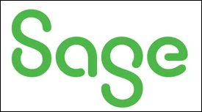 | Sage Intacct specializes in cloud-based financial management solutions, making it an ideal choice for SMEs looking for scalable and agile software. With a focus on automating financial processes, Sage Intacct competes directly with SAP Business One in the SME market.  Sage Intacct's strength lies in its ability to streamline accounting processes, offering real-time insights into financial performance. The platform's cloud-native architecture allows for easy customization and integration, catering to the specific needs of SMEs.
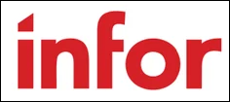 | Infor, with its industry-specific ERP solutions, competes with SAP in serving the needs of large enterprises. Infor CloudSuite, tailored for specific industries, attracts businesses looking for specialized solutions that align closely with their operational requirements.  Infor's industry-specific focus sets it apart, offering solutions like Infor CloudSuite Automotive and Infor CloudSuite Healthcare. Large enterprises benefit from Infor's deep understanding of industry nuances, providing tailored solutions that enhance efficiency and compliance.
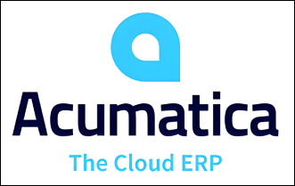 | Acumatica ERP is a cloud-based solution that offers comprehensive functionality for finance, distribution, manufacturing, and project management. It caters to organizations of all sizes, including small businesses and enterprises.
 | Epicor Kinetic is a global, cloud-focused cognitive ERP solution built for manufacturers, driving profitability through real-time insights, people-centric AI, and seamless collaboration. Positioned at the core of your business applications, Kinetic leverages artificial intelligence to extract maximum value from your enterprise data, processes, and decision-making information. Purposely designed with deep industry expertise, it offers end-to-end capabilities for discrete, make-to-order, and mixed-mode manufacturers. Kinetic supports the needs of leading manufacturers across multiple industries, including Industrial Machinery, Fabricated Metals, Electronics and High Tech, Plastics and Rubber, Automotive, Aerospace and Defense, Medical Device, Consumer Products, Furniture and Fixtures, Measuring and Controlling Devices, and more.
- SAP Landscape

In the context of SAP, a landscape refers to the arrangement and structure of SAP systems within an organization's IT environment. It describes how different SAP instances and servers are organized to support development, testing, and production activities.

The SAP landscape is essential for maintaining system integrity, managing changes effectively, and ensuring a smooth flow of operations across an organization.

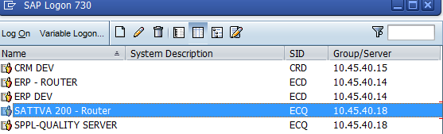

- The SAP Landscape is made up of systems (also called instances) and Clients.
- The system landscape contains all the SAP Systems that have installed.
- It can consist of several system groups, whose SAP Systems are linked by transport routes. After you decide which clients you need and which roles you want them to have, you need to decide how to distribute them amongst the different SAP Systems.
- You can set up multiple clients independently of one another in a single SAP System. However, when you configure the data, you must remember that cross-client Customizing settings and Repository objects are identical for all clients in a single SAP System.
- Changes made in one client apply immediately to all clients in the system.

SAP Architecture refers to the structural design of an SAP system, including the components, layers, and interactions that enable it to function as an enterprise solution. SAP systems are built on a three-tier architecture, which separates data management, application logic, and user interface layers. This design ensures scalability, flexibility, and efficient resource utilization.

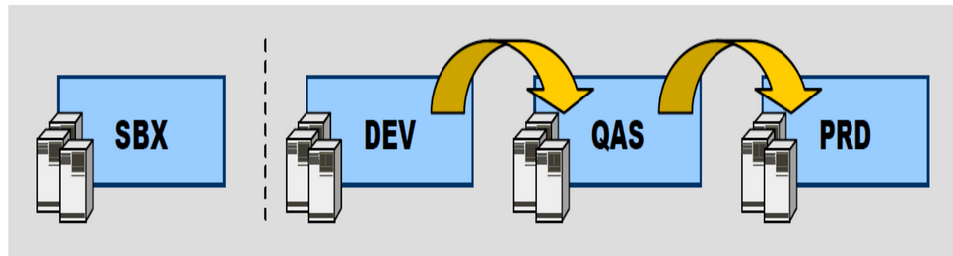
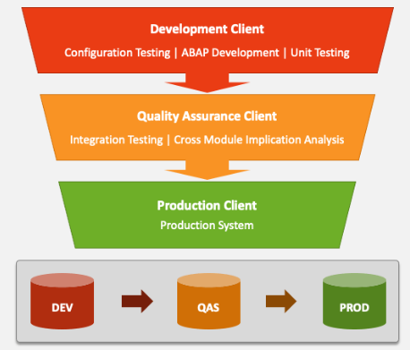

- Sandbox (SBX) server: In the initial stages of any implementation project, you are given a sandbox server where you do all the configuration/customization as per the company’s business process.
- Development Server: – Once the BBP gets signed off, the configuration is done is development server and saved in workbench requests, to be transported to Production server.
- Quality Assurance System (QAS) The Quality Assurance System will be used to support integration testing. It will be configured and developed from the Development system through transports
- Production (PRD) Production Server: This is the last/ most refined client where the user will work after project GO LIVE. Any changes/ new development is done is development client and the request is transported to production
- Training (TRN) The training system will be used to support the effort to train end users on the system.

- SAP Three-Tier Architecture
SAP R/3 is a client/server based application, utilizing a 3-tiered model.
- A presentation layer, or client, interfaces with the user.
- The application layer houses all the business-specific logic,
- The database layer records and stores all the information about the system, including transactional and configuration data.
The R/3 Basis system is a multi-tier client/server system. The individual software components are arranged in tiers and function, depending on their position, as a client for the components below them or a server for the components above them.
The classic configuration of an R/3 System contains the following software layers
The Presentation Layer receives input from a request from the Application layer and displays the same on the user screen.  4  3  The Database layer processes the request from the application layer and sends back the required information | Presentation Layer  0  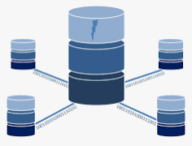  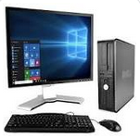  Data Base Layer  Application Layer  2  1 | The Presentation Layer receives input from the user and generates a request  The Application Layer uses the Software Logic Application to receive and process a request  The Database layer contains the central database. It processes the request from the application layer

- SAP S4 HANA Deployment Options

Hybrid
Cloud
On Premise

- On-premise
- An SAP S/4HANA on-premise deployment encompasses traditional in-house IT infrastructure models. This deployment model describes an instance of SAP S/4HANA that is physically hosted on customer property. Customers can choose from a system conversion (brownfield) implementation, which takes an existing SAP environment and transforms it into SAP S/4HANA; a new (greenfield) implementation, which migrates existing business data into a brand-new SAP S/4HANA system; or selective data transition, which uses shell conversion to reuse existing ERP processes in the new system.

- Cloud
- There are multiple cloud options for SAP S/4HANA deployment, all of which involve the use of external cloud integration.
  - An SAP S/4HANA Cloud deployment provides SAP S/4HANA functionality by placing a customer’s instance of the solution on a partitioned cloud server alongside other customers. The functional scope is limited due to its standardized setup.
  - A private cloud deployment provides SAP S/4HANA functionality without the need for the customer to maintain the technical backend. It is great for companies running SAP ERP who already have some cloud experience and infrastructure; with this, they’re able to host the solution on their own cloud without having to share space with other tenants, as the standard SAP S/4HANA Cloud deployment provides.
- The RISE with SAP license provides access to either an SAP S/4HANA Cloud or SAP S/4HANA hosted on a private cloud.

- Hybrid
- A hybrid SAP S/4HANA instance provides a combination of both on-premise and cloud deployments. This may be done for a number of reasons, including testing the feasibility of both instances or hosting an on-premise deployment at headquarters while utilizing a cloud deployment in a satellite office.

Enterprise Managed |  |  | Provider Managed
 | S4 HANA Cloud | S4 HANA on Premise | Hybrid Paas Option | Hybrid Iaas Option
Application
Data
Runtime
Middleware
Operating System
Virtualization
Servers
Storage
Networking
* IaaS Infrastructure as a Service
* PaaS Platform-as-a-Service
- SAP S4 HANA Deployment Models

SAP S/4HANA was designed as a cloud-native solution, offering flexibility to meet diverse organizational requirements. Depending on your business needs, you can deploy it on-premises, in the cloud, or as part of a hybrid cloud infrastructure. Below are the four primary deployment models, along with the possibility of creating custom hybrid configurations:

SAP S/4HANA On-Premises
SAP S/4HANA On-Premises refers to the deployment of the SAP S/4HANA software within an organization's own data center or a hosted infrastructure managed by the organization. This deployment option is designed for companies that prefer full control over their IT systems, data, and infrastructure.
SAP S/4HANA On-Premises is an ideal solution for organizations that need complete autonomy over their ERP system while enjoying the advanced capabilities of SAP S/4HANA.
- In this model, organizations deploy SAP S/4HANA in their own data center using SAP’s Bring Your Own License (BYOL) approach.
- Ideal for companies that prioritize full control over their IT infrastructure and data.
- Key Features of SAP S/4HANA On-Premises:
- Full Ownership: The organization is responsible for managing, maintaining, and customizing the software and underlying hardware infrastructure.
- Flexibility: Allows for extensive customization to meet specific business needs, industry requirements, or compliance standards.
- Control Over Data: Data remains entirely within the organization's data center, offering enhanced control for companies with stringent regulatory or data security requirements.
- Bring Your Own License (BYOL): Organizations can purchase the software license from SAP and deploy it on their infrastructure.
- Upgrade Responsibility: The organization is responsible for applying patches, updates, and version upgrades.
- Use Cases:
- Regulated Industries: Ideal for industries such as finance, healthcare, or government, where data privacy and compliance are critical.
- Custom Business Processes: Suitable for organizations with unique workflows or processes requiring heavy system customization.
- Legacy System Integration: Facilitates seamless integration with existing on-premises systems or legacy applications.

SAP S/4HANA Private Cloud
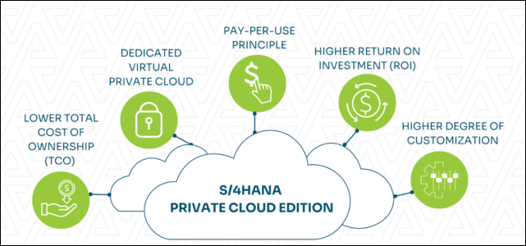

SAP S/4HANA Private Cloud is a deployment model where SAP S/4HANA is hosted on a private, dedicated cloud infrastructure. This setup provides the scalability and flexibility of a cloud environment while offering greater control and customization options compared to public cloud solutions. The private cloud is typically managed either by SAP itself or by a certified cloud provider.
SAP S/4HANA Private Cloud combines the best aspects of on-premises control and public cloud flexibility, making it an excellent choice for organizations seeking a tailored ERP solution with robust scalability and security.
- This option allows businesses to host SAP S/4HANA in a managed private cloud, either through SAP’s enterprise cloud services or third-party cloud providers such as Azure, AWS, Google Cloud, or IBM Cloud.
- Offers a balance of flexibility and control while leveraging cloud scalability.
- Key Features of SAP S/4HANA Private Cloud:
- Dedicated Environment: Unlike public cloud deployments, a private cloud environment is not shared with other organizations, ensuring better control and data privacy.
- Managed Services: The cloud provider (SAP or a third-party) handles most aspects of infrastructure management, including hardware, networking, and backups, allowing businesses to focus on their core operations.
- Scalability: Provides the ability to scale resources (compute, storage, etc.) based on organizational needs without the limitations of on-premises hardware.
- Customization: Allows for more extensive customizations and configurations than public cloud deployments, enabling organizations to adapt the system to their specific business processes.
- Hybrid Capabilities: Can be integrated with on-premises systems or public cloud solutions for a hybrid setup.
- Use Cases:
- Regulated Industries: Ideal for industries like healthcare, banking, and government that need to meet strict compliance standards.
- Global Operations: Suitable for large enterprises with global operations that require seamless integration across regions.
- Custom ERP Solutions: Best for businesses that require a high level of customization while benefiting from cloud scalability.

SAP S/4HANA Public Cloud (Multi-Tenant)
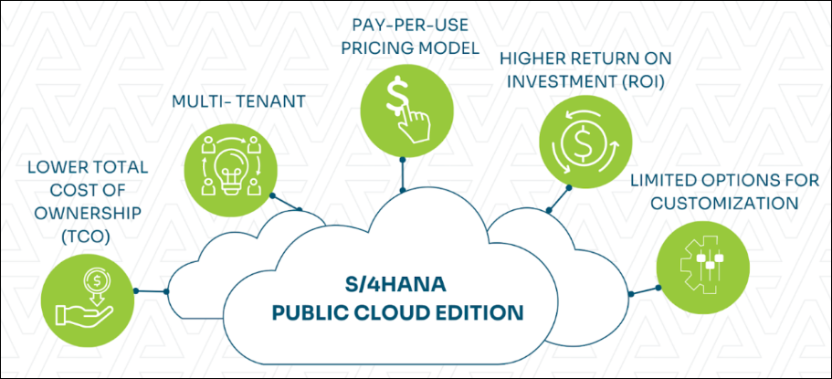
SAP S/4HANA Public Cloud (Multi-Tenant) is a deployment model where multiple organizations (tenants) share the same cloud infrastructure and resources, managed by SAP. This Software-as-a-Service (SaaS) solution offers a cost-effective way to run SAP S/4HANA with standard processes and minimal customization, making it ideal for businesses seeking simplicity, scalability, and faster deployment.
SAP S/4HANA Public Cloud (Multi-Tenant) is a cost-effective and scalable SaaS solution, designed for businesses that can operate with standardized processes and prioritize simplicity over extensive customization.

- A SaaS (Software as a Service) offering where multiple organizations share the same infrastructure.
- Supports an SAP S/4HANA On-Premises Edition hosted in the public cloud.
- Note: Some industry-specific functionalities may not be available in this model.
- Key Features of SAP S/4HANA Public Cloud (Multi-Tenant):
- Shared Infrastructure:
- Multiple tenants (organizations) share the same cloud platform, with data securely isolated for each tenant.
- Infrastructure is fully managed by SAP, including updates and maintenance.
- Standardized Processes:
- Built on SAP’s best practices, this deployment is designed for businesses that can operate with minimal customization.
- Focuses on standardized, industry-specific functionalities.
- Rapid Deployment:
- Offers pre-configured solutions for faster implementation.
- Ideal for businesses looking for quick time-to-value.
- Cost-Effective:
- As a SaaS solution, it eliminates the need for upfront investments in hardware or infrastructure.
- Subscription-based pricing reduces total cost of ownership (TCO).
- Automatic Updates:
- SAP handles regular software updates, ensuring businesses always have the latest features and innovations.
- Use Cases:
- Small and Medium Enterprises (SMEs):
- Ideal for SMEs seeking a modern ERP system without the complexity of managing infrastructure.
- Fast-Growing Businesses:
- Organizations that need a scalable ERP solution to grow quickly while keeping costs low.
- Global Teams:
- Businesses with remote teams or multiple offices can benefit from centralized, cloud-based access.

SAP S/4HANA Public Cloud (Single Tenant)
SAP S/4HANA Public Cloud (Single Tenant) is a deployment model where a single organization (tenant) uses a dedicated instance of the SAP S/4HANA solution within the public cloud. Unlike the multi-tenant public cloud, the single-tenant model provides enhanced control, greater customization options, and additional flexibility while still leveraging the benefits of a cloud-based SaaS (Software-as-a-Service) solution.
SAP S/4HANA Public Cloud (Single Tenant) offers a balance between customization and cloud efficiency, making it an excellent choice for businesses that need a dedicated, secure, and flexible ERP solution without the overhead of managing on-premises infrastructure.
- A SaaS subscription model providing access to the full functionality of SAP S/4HANA, including new public cloud capabilities.
- Implementation and system management are fully handled by SAP.
- Suitable for businesses seeking the advantages of SaaS while maintaining dedicated infrastructure.
- Key Features of SAP S/4HANA Public Cloud (Single Tenant):
- Dedicated Instance:
  - Each organization operates its own instance of SAP S/4HANA within the public cloud infrastructure, ensuring data and configurations are isolated.
- Customization:
  - Offers more extensive customization compared to the multi-tenant model, allowing organizations to tailor the system to their specific business processes.
- Managed by SAP:
  - SAP handles system management, updates, and maintenance, reducing the organization’s IT burden.
- Scalability:
  - Combines the scalability of a public cloud with the control of a dedicated environment.
- SaaS Model:
  - Operates as a subscription-based service, eliminating upfront costs for hardware or infrastructure.
- Key Features of SAP S/4HANA Public Cloud (Single Tenant):
- Dedicated Instance:
  - Each organization operates its own instance of SAP S/4HANA within the public cloud infrastructure, ensuring data and configurations are isolated.
- Customization:
  - Offers more extensive customization compared to the multi-tenant model, allowing organizations to tailor the system to their specific business processes.
- Managed by SAP:
  - SAP handles system management, updates, and maintenance, reducing the organization's IT burden.
- Scalability:
  - Combines the scalability of a public cloud with the control of a dedicated environment.
- SaaS Model:
  - Operates as a subscription-based service, eliminating upfront costs for hardware or infrastructure.

Hybrid Configurations
Many organizations prefer hybrid deployments, combining on-premises and cloud solutions. For instance:
- A financial services company might host a new SAP cloud CRM solution on a public cloud platform (e.g., Azure) while retaining sensitive customer databases on-premises to comply with regulatory requirements.

Two-Tier ERP Deployment Model
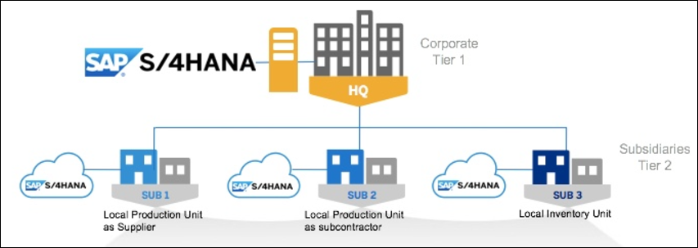
- For larger enterprises, the Two-Tier ERP model is a strategic approach to streamline operations across headquarters and subsidiaries. This model leverages SAP S/4HANA's integration capabilities in both on-premises and cloud editions, offering flexibility to harmonize processes across different deployment scenarios.
- By choosing the right combination of deployment models, businesses can effectively balance operational needs, cost, and compliance requirements.
- The SAP S/4HANA Two-Tier ERP Deployment Model refers to a strategic approach where an organization deploys two distinct ERP systems to manage operations across its headquarters (Tier 1) and subsidiaries, branches, or divisions (Tier 2). This model is designed to address the differing operational, financial, and compliance needs of central and regional entities while ensuring seamless integration and harmonization of data and processes.
- The SAP S/4HANA Two-Tier ERP Deployment Model is an innovative approach that enables organizations to strike a balance between global standardization and local flexibility. It is particularly beneficial for businesses with diverse operational needs across multiple entities, offering scalability, efficiency, and improved operational oversight.
- Key Features of the Two-Tier ERP Deployment Model:
  - Tier 1 (Headquarters ERP):
  - A comprehensive and robust ERP system, often deployed on-premises or in a private cloud.
  - Supports centralized operations, advanced analytics, and global compliance.
  - Tier 2 (Subsidiary ERP):
  - A leaner, more agile ERP system, typically deployed in the cloud to meet the localized needs of subsidiaries or smaller business units.
  - Focuses on operational efficiency, quick deployment, and cost-effectiveness.
  - Seamless Integration:
  - Tier 1 and Tier 2 systems are integrated to enable real-time data exchange, consistent reporting, and centralized oversight.
  - Flexibility in Deployment:
  - Subsidiaries can choose between SAP S/4HANA Public Cloud, Private Cloud, or On-Premises deployment options depending on their specific needs.
- Use Cases:
  - Global Enterprises:
  - Large multinational corporations with multiple subsidiaries or divisions operating across different regions.
  - Mergers and Acquisitions:
  - Businesses acquiring new subsidiaries can quickly integrate them into the existing ERP ecosystem using a Tier 2 deployment.
- Industry-Specific Requirements:
  - Industries like manufacturing, retail, or distribution, where subsidiaries often have unique operational needs.

